Why I made this

I was using spotify and was bored and challenged myself to make a small mvp version of how the Playlist works and also used it as practice for working with vectors, randomness algorithms and oop concepts;

How it works

Basically you make changes to your Blank Playlist by adding new songs, removing songs, searching for songs then after you can then access in the Playlist Menu by using functions such as "play song" or "show playlist duration" It works in a Linear Fashion so once you add songs and make changes to your playlist you can't go back

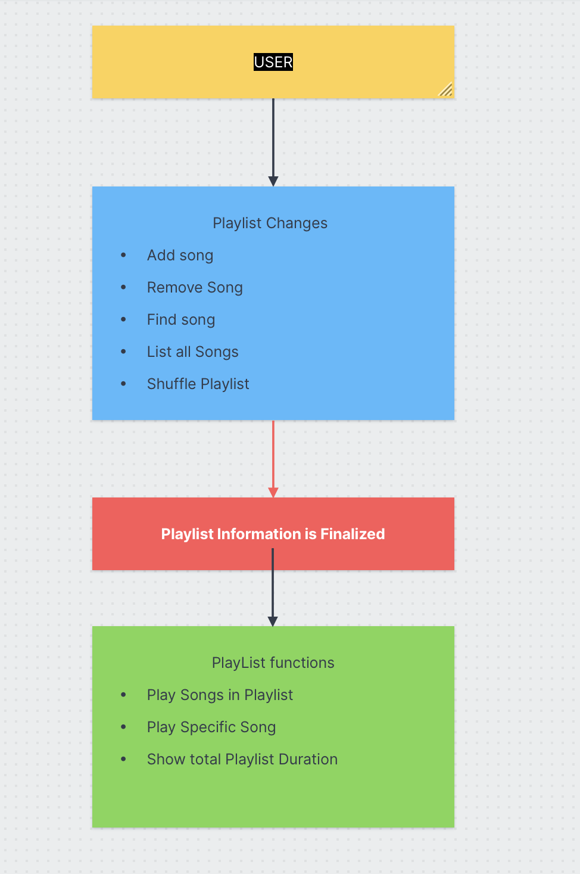

How to use

Simply Download the folder and run it on your IDE of choice or terminal if you feel like it

How it Looks

